Rigaku Reactor-X High Temperature stage

Information for users

Sample preparation.
A typical sample preparation involves pressing 2-3 spatula heads worth of powder into the 20×10×1 mm recession in a supplied black quartz sample holder (Figure 1).
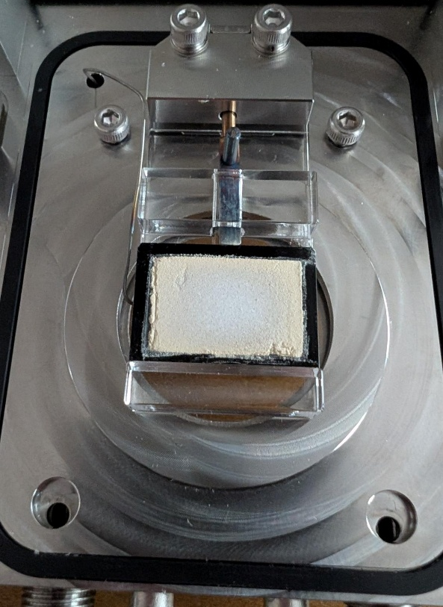
Figure 1 Typical sample loading inside the Reactor-X
This is approximately 150 mg but depends heavily on the density of the powder. The powder is recoverable at the end, albeit having gone through the heat treatment. A thermocouple wire is inserted into a hole in the body of the sample holder, which records the temperature. The sample is heated by an infrared bulb shining from underneath

Air sensitive samples
Samples are typically mounted on the bench in ambient conditions but the reactor-X stage has a detachable-sealable unit which contains the sample: see Figure 2 (left) approx. 150×150×300 mm. This unit can be taken into a glovebox so the sample can be mounted and sealed in inert conditions. Be aware that sealed (Swagelok quick connect) pipes containing water will also need to be brought into the glovebox. Use a gas purge only procedure rather than vacuum/purge cycle to bring the stage through the antechamber.
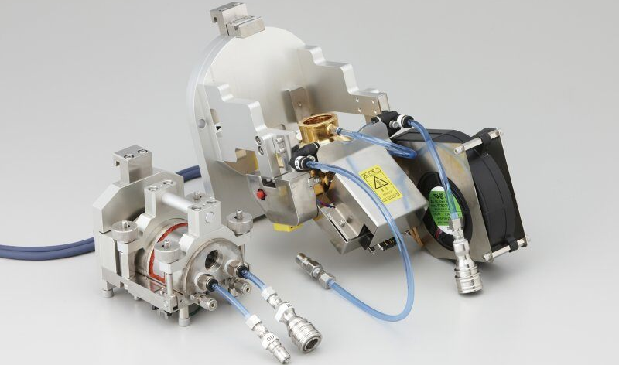
Figure 2 Reactor X sample stage. The sample enclosure (left) can be separated from the heating stage (right) whilst mounting the sample

Not enough sample
If you don’t have enough sample to fill the holder your two options are:
- To spread what you have across the base of the sample holder. The disadvantage of this is that you won’t be able to accurately align the sample and may have larger zero error shifts which could prevent you from accurately modelling your lattice parameters as a function of temperature. You could consider using a parallel beam setup to reduce the error associated with the sample height change (see section 1.2).
- To press the powder you have into a smaller area within the recession to be still level with the top of the sample holder, and we can reduce the size of the beam to match. This will increase the required collection time but it’ll still be possible to automatically adjust the sample height to minimise sample height errors.

Outgassing samples
Samples which contain large amounts of water or that otherwise outgas are susceptible to cracking of the surface of the pressed powder, see Figure 3. If this occurs it can ruin the data collection by anomalously shifting the peaks and changing their intensity. It is difficult to predict when this will be an issue, but if you suspect your sample could be susceptible, then a test you can do to save instrument time (and my time) is to lightly press a small amount of the powder into the bottom of a crucible and observe if it cracks and buckles under identical heating conditions in a furnace.
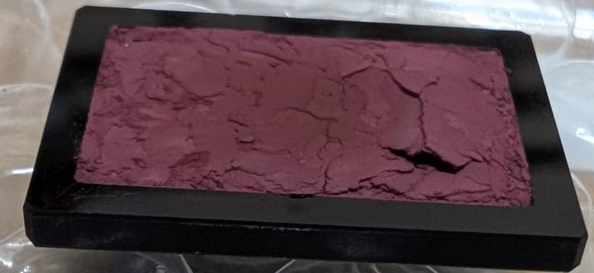
Figure 3 cracking of the sample surface due to outgassing, this leads to a sample height error in the measurement which gives a non-trivial shift in the diffracted peak positions

Mitigation against cracking
- Remove a couple of mm of powder from the edge of the sample holder to create some room for swelling. In extreme cases this won’t be effective.
- Spread only a thin layer of powder across the base of the sample holder. The disadvantage of this is that you won’t be able to accurately align the sample and may have some larger zero error shifts which could prevent you from accurately modelling your lattice parameters as a function of temperature. You could consider using a parallel beam setup to reduce the error associated with the sample height change.

Non-powder samples
The hot stage works by an infrared bulb heating a black quartz sample holder that has a little hole in it for a thermocouple to be inserted into (Figure 1). The powder sample rests in a recession at the top of the sample holder.
Only powders have been measured in the stage at the time of writing. If your sample is a thin-film coated on a substrate then measuring it might be possible if:
- The substrate can be of a material that absorbs IR radiation,
- The substrate can be made the same size as the standard black quartz sample holder, and
- A small hole can be bored in the side of the substrate to fit the thermocouple in.
In the event those three conditions can be met, you’ll also need to measure a standard with known thermal expansion coefficient in similar conditions so that you can accurately determine the temperature on your custom sample holder.
similarly, if the sample is a bulk material, then it needs to be made to fit in the standard sample holder or a custom sample holder will need to be made.
You might also enquire if Rigaku offer any existing solutions by contacting their sales team through their website.
I am not going to do any of these steps for you. If you come to me with a viable option then I’ll help you from there on.

Sample height error
Thermal expansion of the sample and environment will cause the sample position to move slightly. Crucially, vertical motion will affect the position of the peaks due to a sample height error, similar to a zero shift error of the entire pattern left or right. This error can be minimised by aligning the sample at each temperature that is being measured.
The alignment step assumes that the sample is sitting at the same height or higher than the sample holder, which is generally true when pressed level with the sample holder. If it is sitting lower, you will align to the sample holder instead, which will generally produce an almost systematic error in the sample height: a constant zero shift error across all measured patterns. However if the sample’s thermal expansion is different from the sample holder the error will veer off systematic.
If you do not adjust the sample height at all across a temperature range then you will introduce a height error that’s an unknown function of temperature, and the zero shift will differ across each collected pattern. This error is refinable but will correlate to your refined lattice parameters.
One option to avoid sample height error is to use a parallel beam setup, which removes the height error from consideration, although alignment may still be recommended since the beam isn’t perfectly parallel. The downside of this is a sacrifice of intensity and resolution.

Measurement conditions
The sample surface (which is measured by the X-rays) is open fully to whatever environment is inside the sample chamber. This can be open or sealed and with or without a gas flow. The sample is heated from below as previously discussed.

Available environments:
- Open to air (via an open 1/8” pipe).
- Nitrogen flow (slow flow, max 200ml/min)
- Sealed under air, nitrogen or the loading gas, with an overpressure release at 1.03bar.The chamber will likely outgas on heating then form an under-pressure on cooling.
- *Under static or dynamic vacuum (~ 10⁻² mbar).* This option is listed in parts of Rigaku’s datasheets for the stage but some application scientists appear unaware of it. Its safe use will need to be confirmed before first use.
Other gases are compatible with the sample chamber, including reactive gases, but are not supplied in the room. If you wish to perform an experiment under a different gas flow you can enquire but crucially there is no extraction in the room so any hazardous gases would need a rigorous plan to handle the exit gas. This would be for you to explore, then bring to me once your control measures have been confirmed as feasible by the safety team: I’m not going to look into it for you.

Temperature control
Temperature range
between room temperature and 950°C (notionally 1000°C but higher risk of not stabilising and higher risk of degrading the stage).
Ramp rate
between 1 and 300 °C per minute, up and down (max rate of 300 may not be achievable when heating to the highest temperature or cooling back down to room temperature).
Dwell times
Any dwell time can be included to stabilise the temperature and/or anneal the sample.
Logging
A log file can record the temperature of the stage as a function of time alongside measurements. The measurement sequence can be saved in your own folder for future reference.

Data collection strategy
The stage can be programmed to heat, align, stabilise, and measure in most desired sequences. The most common data collection strategy is to ramp to a target temperature, dwell for the temperature to stabilise (either idle or taking consecutive quick measurements while it stabilises), run a quick alignment of the sample height, then measure a pattern before changing to the next temperature and repeating. You can alternatively measure quick patterns continuously while sweeping the temperature but data collection times aren’t usually fast enough for decent temperature/temporal resolution (unless opting for a low-resolution mode, d,e in see section 1.5 below).

Beam setup
The instrument is equipped with a Cu source, with several optics options these can be approximated as follows:
- Good intensity, good resolution Cu K_{α1,2} akin the facility’s Bruker diffractometer. Typically 10-30 minutes per good quality collection. The default option.
- Ok intensity, higher resolution Cu K_{α1} akin the facility’s Empyrean. Typically 40-120 minutes per good quality collection.
- Ok intensity, Ok resolution Cu K_{α1,2} parallel beam. Typically 30-60 minutes per good quality collection. Advantages of the parallel beam include a low sensitivity to sample height alignment changes and ability to collect in grazing incidence.
- Rapid data collection, Low resolution. Typically 30-600 seconds per decent intensity data collection. The instrument can be configured with a parallel or pseudo-point beam and the detector can be moved closer to the sample to decrease collection time at the sacrifice of peak width resolution.
- Fastest data collection, low resolution, limited 34° 2θ angular range. 10-60 seconds per measurement. Instrument configured with a pseudo-point beam and the detector moved close to the sample and kept in a fixed position. As above but with limited angular coverage.
If using a point beam and close detector setup it is very important that the powder sample is extremely well ground (grind it thoroughly for 20 minutes). If any large grains are in the point beam the peak intensities will be meaningless.
These setups are physical configuration changes, you cannot change between them during the data collection procedure without cooling down and removing the heating stage.

Applying for an experiment
When a user has read and understood the information in section 1 and wishes to conduct an experiment using the variable temperature stage, they should fill in and return sections 2 and 3 to Simon Cassidy. Sections 2 and 3 also need to be checked and signed off by your academic supervisor or any member of your group that is allowed to sign off risk assessments (an email acknowledging that what you’ve entered is accurate is fine).
Retain an electronic copy for yourself to save time if you wish to repeat an experiment and you have already done this. There is no need to repeat the sign-off steps if the chemistry and conditions are unchanged.
Your name and research group

Sample composition include chemical composition(s) and any meaningful descriptors if appropriate

Is the sample air sensitive?
Yes / No (delete as appropriate)
Desired environment (see section 1.2.1)

Desired beam configuration (a-e, see section 1.5)

Outgassing Is the sample likely to lose gas? If yes have you tested to see if the sample surface is likely to deform on heating? See section 1.1.4

Reaction/decomposition/outgassing products (including absorbed water/solvent or gaseous products)

Desired outcome from the measurement briefly describe what you’re hoping to determine from the data once it’s collected

Experiment heating and measurement procedure
The table below is for you to fill in: Add as many lines as are appropriate. Include cooling to 25°C as your last step. Min and Max temps are 25 and 950 and ramp rates are 1 and 300 as detailed in section 1.2.2
Temperature (°C) | Approaching Ramp rate (°C/min) | Short Measurements during ramp? | Hold time at temperature (min) | Short measurements during hold? | Long measurement after holding?
25 | 5 | No | 0 | No | Yes
Estimated total time =
An Example, delete before returning:
Temperature (°C) | Approaching Ramp rate (°C/min) | Short Measurements during ramp? | Hold time at temperature (min) | Short measurements during hold? | Long measurement after holding?
25 | 5 | No | 0 | No | Yes
500 | 30 | No | 10 | Yes | Yes
25 | 1 | Yes | 0 | No | No
Estimated total time = 561 minutes
Calculation (assuming beam setup a and 30 minutes per long measurement):
(25-20)/5 minutes to ramp from 20 to 25°C at 5°C/min + 30 minutes long measurement + (500-25)/30 minutes to ramp to 500°C at 30°C/min + 10 minutes hold time + 30 minutes for a long measurement + (500-475)/1 to ramp back to 25°C at 1°C/min = 561 minutes.

Grant code:

Explanation of funding model for internal users: The department spends money running communal research facilities like the X-ray diffractometers. The departments policy is that these Small Research Facilities (SRFs) are “free at point of use” for its researchers but it will try to apportion the cost of running the instruments to the research grants of its users wherever possible. Funding on a research grant is typically divided into different tasks according to what the grant application specified the award would be spent on, and sometimes this is can include a budget for using SRFs. E.g. .CO for consumables, .TV for travel, .RF for small research facility use.
When you put down a grant code to book SRF time:
- Grants with SRF ringfenced funds: the money will be charged straight away/end of month.
- Grants without SRF ringfenced funds: no money will be charged. If there is an unspent consumables budget when the grant is ending then the unspent money can be taken for past measurements. So please do put down a grant code even if it doesn’t have specific SRF funding.
- No grant: acceptable but please see above.
Costing of the experiment: Instrument rate is £29.40 per hour (don’t worry about this see explanatory note above). In addition to the measurement time, include one additional hour to cover installation and subsequent removal of the high temperature stage. If opting for beam setup b,d, or e include one more additional hour.
Other relevant information (optional):

Risk Assessment / Reaction Hazards Declaration
The user should rely their own risk assessment for safe handling of the material in question. The following assesses whether the sample poses a risk to people in the room or could cause damage to the instrument under the proposed experimental conditions.

Anticipated conditions
Under the anticipated operation conditions, the sample will be heated to the desired temperature in the desired gaseous environment as the user has described in section 2. The powder will be in physical contact with a black quartz sample holder and the gaseous environment described. Any released gases will also make contact with the main body (stainless steel), the inlet/outlet gas tubes (stainless steel), the X-ray window (beryllium) the thermocouple (Ni/Cr), the viewing and heating bulb windows (transparent quartz glass), and small brass parts.
Under open-to-air conditions, any gases expelled will be able to exit directly from the front of the chamber into the instrument enclosure. Under gas flow conditions, the gas in question and any gas expelled from the sample will exit the chamber via a long stainless-steel capillary to the rear of the instrument. Under seal chamber conditions, any expelled gas will largely remain within the sample chamber until it is opened or purged, but some may exit the chamber via the exit gas capillary if the pressure exceeds the limit on the overpressure valve (1.03bar).
1. Could the sample or its gaseous products react with, or cause damage to, the sample environment under the anticipated operational conditions?
Yes / No (delete as appropriate)
1.a. Provide details if answering Yes to question 1:

2. Will your sample produce any gases under the anticipated conditions?
Yes/No (delete as appropriate)
2.a If answering yes to question 2, are any of these gases hazardous?

2.b If answering yes to 2.a. detail the hazards, and calculate the expected number of milligrams and ppm concentration of each hazardous gas released (see appendix).

The gases will vent into the X-ray room. If you have answered yes to question 2.a. then your experiment might need further consideration. Carcinogens, mutagens or asthmagens must be controlled to as low as is reasonably practicable, which means if these are expected to be produced then there must be a suitable capture mechanism or the experiment cannot be performed. (n.b. Calculation is unnecessary for CO₂ released from a solid as the release can’t typically exceed 10ppm)

Unanticipated conditions
In the case of a fault:
- The sample could be heated to 1100 °C (very low possibility).
- If the chamber is not sealed correctly air could leak into the sample chamber (more plausible) and gases could leak out of the sample chamber into the instrument enclosure.
- The sample could also lift off the sample holder and spread inside the sample chamber, making physical contact with the other internal parts (stainless steel, beryllium, Ni/Cr, quartz glass, and brass).
1. Could the sample or its gaseous products react with, or cause damage to, the sample environment under the unanticipated operational conditions?
Yes / No (delete as appropriate)
1.a. Provide details if answering Yes to question 1:

2. Would your sample produce any gases under the unanticipated conditions?
Yes / No (delete as appropriate)
2.a If answering yes to question 2, are any of these potential gases hazardous?

2.b If you have answered yes to question 2.a. Detail which gas(es) could be produced and the hazards. Calculate the potential concentration of the gas produced. See The appendix for assistance with this.

If you have answered yes to any of the questions in section 3.2 you might be required to take suitable steps to mitigate against any risk e.g. modify the experimental procedure, monitor your experiment closely during collection, or only carry out the experiment during working hours. This depends on the risks and hazards involved.

Additional comments including other reaction hazards (optional)
If you feel there is anything important to add about your sample please do so here.

Appendix. hazardous gas safety limits:
If your sample is expected to release a hazardous gas then calculate the potential ppm exposure. You’ll need to work out the mass or number of moles of gas that will be released from your sample. Assume you have place 200mg of your powder in the sample chamber.
The volume of the room is approximately 108 m³. Air does circulate and leave the room via the air conditioning unit but for the purposes of the calculation assume a rapid and complete expulsion of the gas from the sample causing all the potential outgas released to localised in 1/8th this volume (13.5 m³), remaining for a significant time.
$ppm= \frac{24.45×mass(mg)}{13.5×Molecular Weight (g/mol)}=\frac{1.311*mass(mg)}{Molecular Weight (g/mol)}= \frac{moles}{0.001311}$
Where the mass/molecular weight/moles are those of the gas released (not the sample).

See EH40/2005 Workplace exposure limits page 9-21, low-resolution copy below. Does this ppm value exceed a safe limit? If it does then consider how this could be brought to a safe level? n.b. release of any Carc or Sen gases is not permitted

